- Lab Task 1:
Write a SQL statement for HR department to produce the addresses of all the departments using the LOCATIONS and COUNTRIES tables.
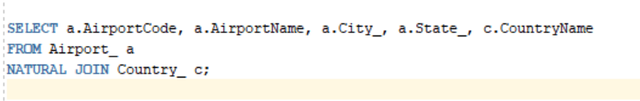

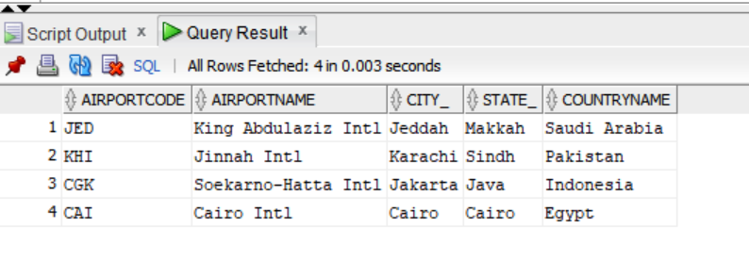
OUTPUT:

